Wind Turbine Failure Analysis

1.Project Overview
The wind turbine failure analysis project aims to process and analyse large volumes of data generated from turbine operations, gearbox conditions, temperature logs, and performance metrics. Managing this data effectively is crucial for identifying failure patterns and improving turbine efficiency. However, the existing data handling methods are not efficient enough to manage the growing volume and complexity of datasets.
2.Dataset Summary
-Rows: 26282
-Columns:16
-Key Features:
Date (Timestamp of each turbine reading.
Wind Speed (Speed of wind hitting the blades)
Wind Direction (Direction of incoming wind)
Yaw Angle (Turbine alignment angle with wind flow)
Power (Generated power output)
Rotor Speed (Speed of main rotor rotation)
Generator Speed (Speed of generator shaft)
Ambient Temperature (Outside environmental temperature)
Nacelle Ambient Temperature (Temperature around nacelle exterior)
Nacelle Temperature (Internal nacelle temperature)
Generator Bearing Temperature
Bearing Temperature
Gear Oil Temperature
Gear Box Inlet Temperature
Wheel Hub Temperature
Failure status 0 = No Failure, 1 = Failure
-Missing Data: 522 values in Wind speed column
518 values in Power column, 525values in Nacelle ambient temperature,
525 values in Generator bearing temperature , 520 Gear oil temperature,
517 values in Ambient temperature, 517 Rotor Speed ,525 values in Nacelle temperature ,525 Bearing temperature, 519 values in Generator speed,525 values in yaw angel ,Wind direction ,Wheel hub temperature, Gear box inlet temperature.
3. Exploratory Data Analysis using Python
We began with data preparation and cleaning in python:
- Data Loading: Imported the dataset using pandas.
- Initial Exploration : Used df.info() to check structure and .describe() for summary statistics.
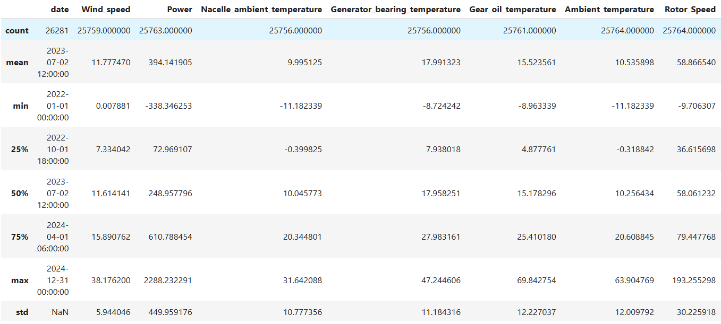

- Missing Data Handling: Checked for null values and imputed missing values in the Review Rating column using the median rating of each product category .
- Column Standardization: Required columns to snake case for better readability and documentation.
After that I perform first moment business, and mined mean and median values for dataset
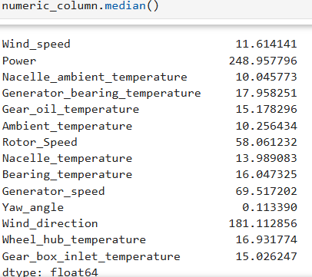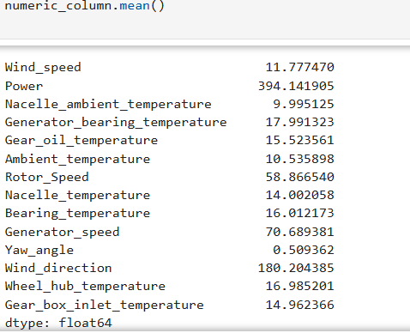
After that I perform Second moment business, and mined mean and median values for dataset
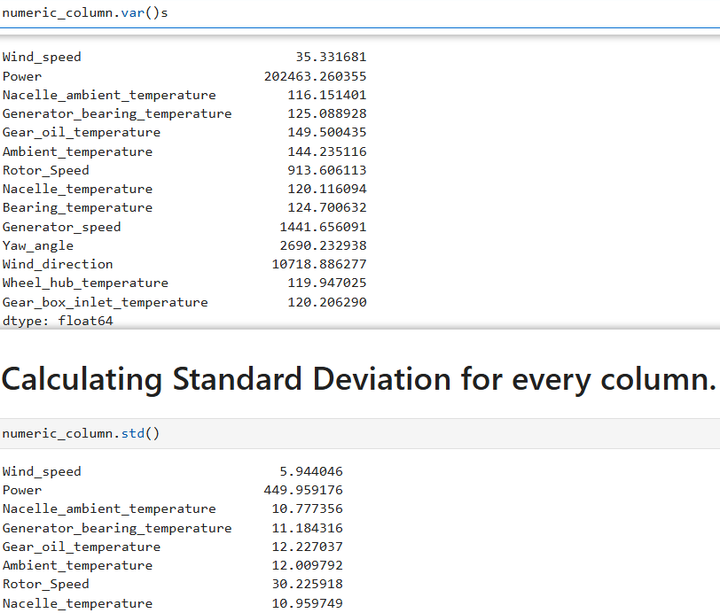

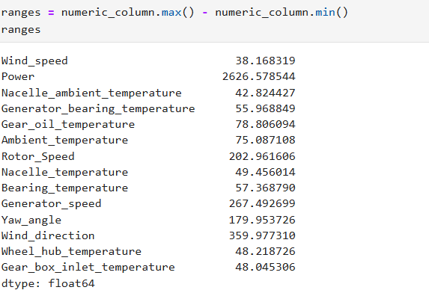
After that I perform Third moment business, Fourth moment business, and mined mean and median values for dataset
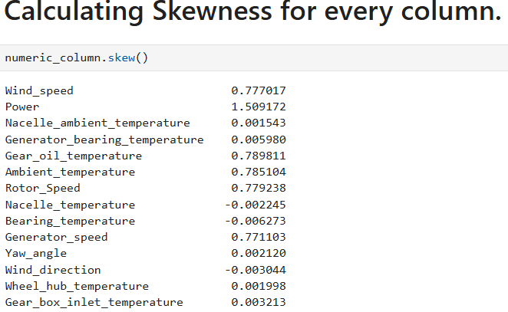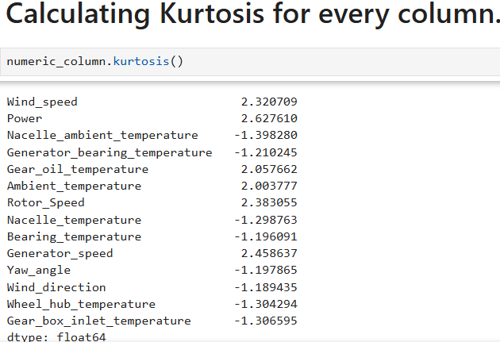
After that I perform Graphical representation .
In which first I Find histogram of column wind speed for checking the distribution of data column.

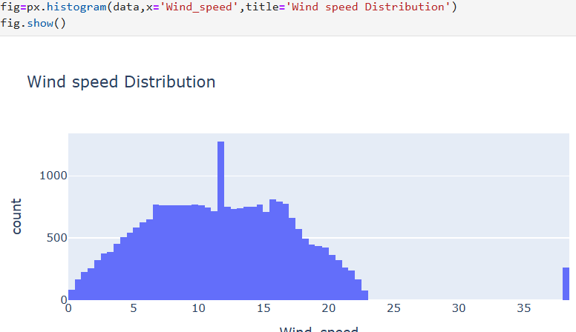

Then For outlier treatment I use winsorization method .
First I check outliers present or not for that I use boxplot.

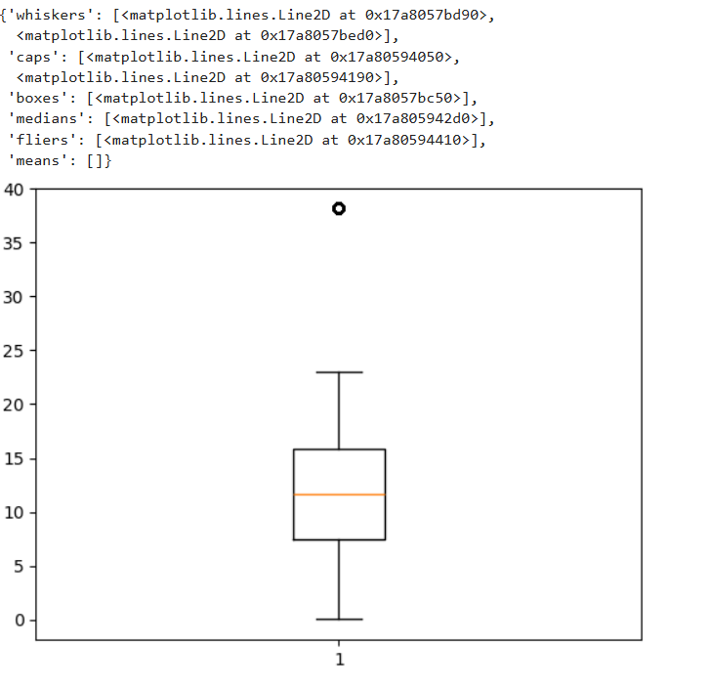
After checking I use winsorization method.
5. Wind turbine failure Analysis Dashboard of Power bi
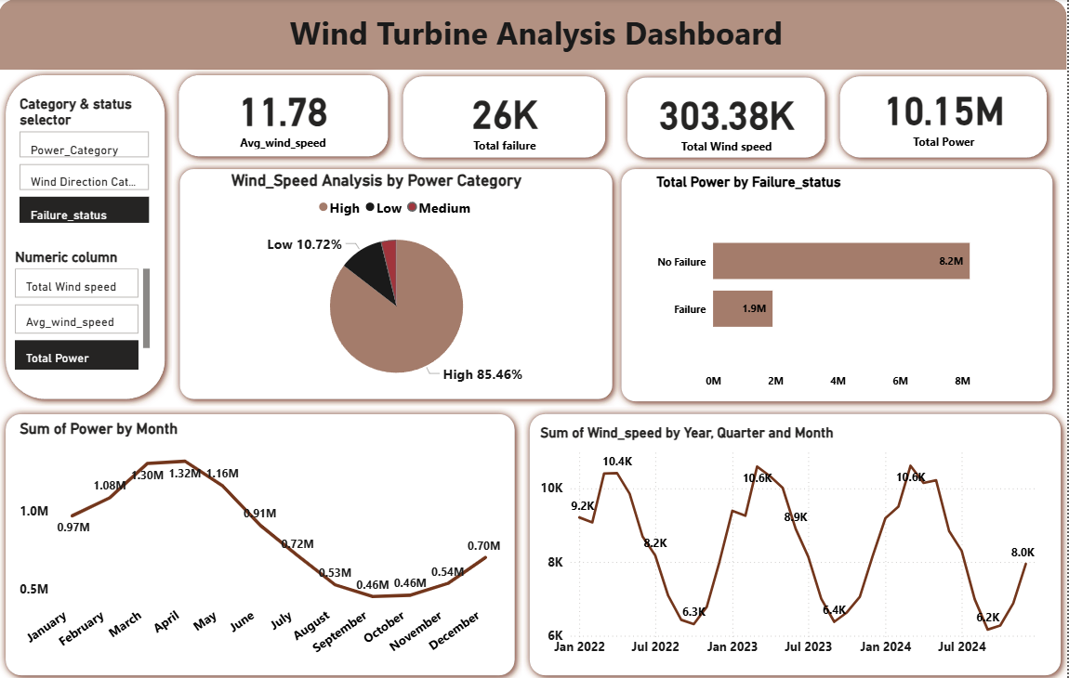
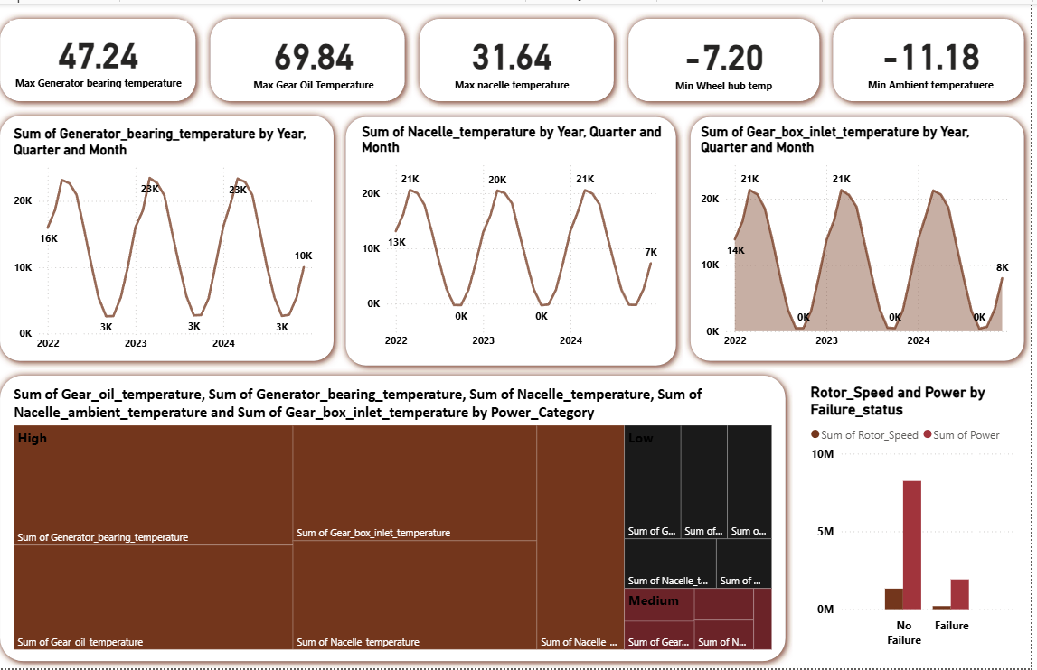
6.Buisness Recommendations
- Optimize Preventive Maintenance – Use temperature and vibration patterns to schedule maintenance before failures occur, reducing downtime.
- Enhance Turbine Alignment – Monitor yaw angle and wind direction mismatch to ensure the turbine is always aligned for maximum power output.
- Improve Component Cooling Systems – High generator and gearbox temperature readings suggest the need for better cooling or lubrication systems.
- Boost Power Efficiency – Analyze power vs. wind-speed curves to identify under-performing turbines and calibrate rotor or generator settings.
- Failure Prediction Alerts – Use Failure_status patterns to create early warning alerts for upcoming failures, improving safety and reliability.

